Dear Future Resident,

Thank you for visiting 2110-2112 Frisch Road. If you would like to submit an application, please follow the two easy steps below.

Step 1: You can find these properties on www.Zillow.com. Click on Rent.
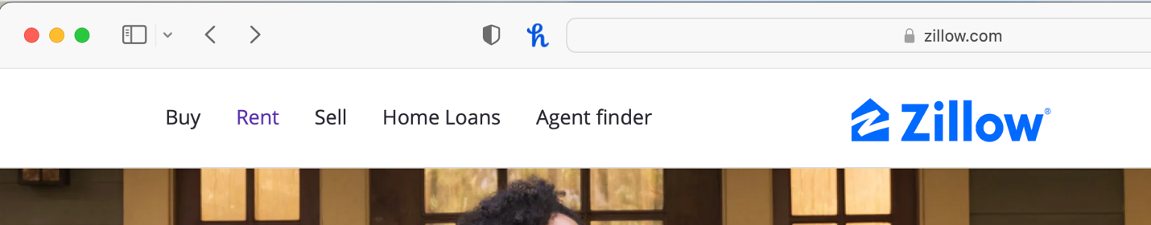

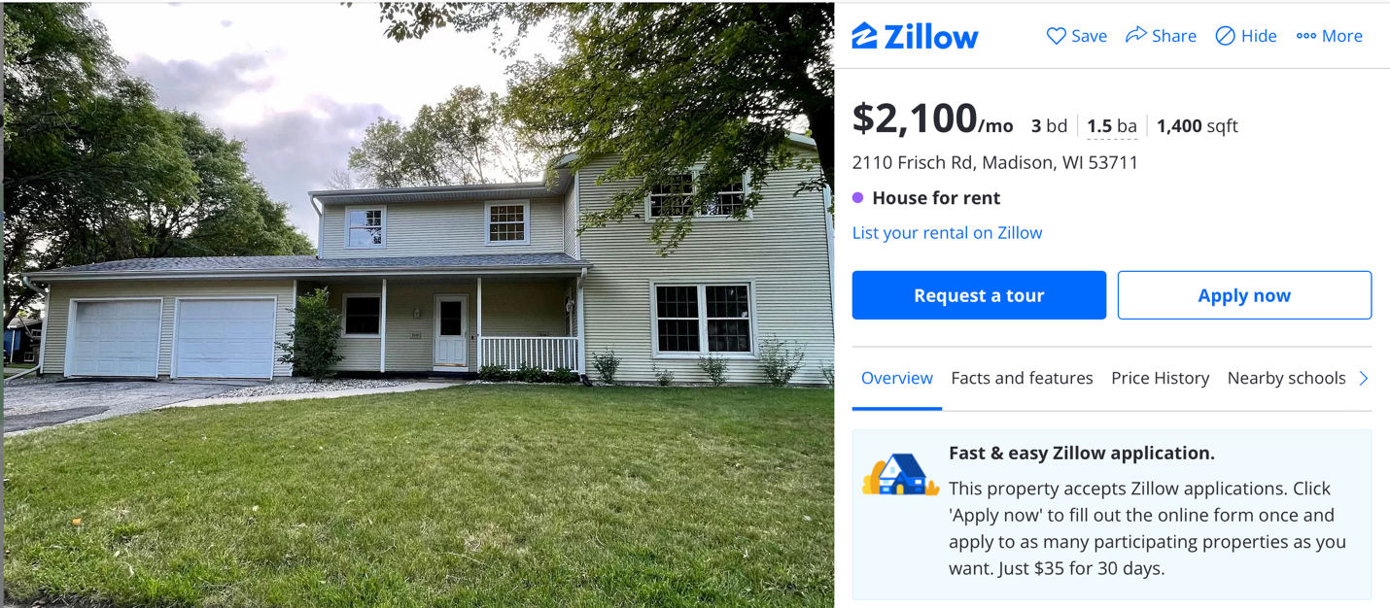
Step 2: Search for 2112 Frisch Road or 2110 Frisch Road. This screen below should pop up. Click Apply now.

If you need any help through this process please reach out to frischroadllc@gmail.com or text at +1 208 608 6737 and include your name and email. The owner will send you an email with an invitation to apply.

Thank you for your interest and we look forward to working with you!

Sincerely,
Kevin

